An Explainable Machine Learning Clinical Decision Support System with Clinical Regularization and Youden-Thresholding for Bedside ICU Mortality Prediction
S. Kaviya Shree (24BVD1088), D. Tarunika (24BLC1336), Kavya Raja . G (24BVD1099)
School of Electronics Engineering, Vellore Institute of Technology (VIT), Chennai, Tamil Nadu, India
Email: {kaviyashree.s2024, tarunika.d2024, kavyaraja.g2024}@vitstudent.ac.in
Abstract—The ability to predict reliably if ICU patients are likely to deteriorate is critical in order to improve the outcomes of their treatment. Unfortunately, existing alarm systems have a lot of false positives causing alert fatigue in clinicians. In our paper, we describe the development and implementation of a real-time Clinical Decision Support System (CDSS) for prediction of in-hospital mortality using physiological measurements collected within the first 24 hours after ICU admission. By using the MIMIC-IV Clinical Demo dataset (100 patients, 140 ICU stays), we built a robust preprocessing pipeline with the steps of outlier filtering, conversion of units of temperature, and multimodal statistical aggregation (min, max, mean, standard deviation, latest measurement, and trend) of 9 clinically validated biomarkers. We assessed seven different machine learning algorithms and two ensembles by using Stratified 5-Fold Cross-Validation and cost-sensitive class weights. Due to the problem of class imbalance (mortality 10.72%) and to avoid thresholding errors, we performed out-of-fold Youden's J 99-step threshold sweeps. The best-performing predictor proved to be ExtraTrees Classifier, which achieved the optimal decision threshold of 0.39 and hold-out performance of 0.5556 (ROC-AUC), 0.1603 (PR-AUC), and 0.5000 (Sensitivity/Recall) for the prediction of mortality. Our system provides explainability at the point of care with the help of Game-theoretic SHAP Explainability Engine that translates risk scores into natural language explanations of the biophysical predictors like Potassium (Min), BUN, and Systolic BP.
Keywords— Explainable Artificial Intelligence (XAI), Clinical Decision Support Systems (CDSS), Logistic Regression, Youden's J Statistic, SHAP Swarm Density, ICU Mortality Prediction, MIMIC-IV Clinical Demo.
I. Introduction
In critical care settings, continuous monitoring and clinical interventions are required due to the high acuity of ICU patients' conditions. Critical care providers have to process large amounts of heterogeneous data from bedside monitors, ventilators, laboratory tests. Management of this information can result in cognitive overload and alarm fatigue that might lead to clinicians' insensitivity to the frequent alarms and possible neglect of early warnings about patients' physiological deterioration.
Machine learning and CDSS can solve these problems through provision of automatic, scalable support in patient monitoring. Using EHRs to discover meaningful physiological patterns and risk factors, these approaches allow identifying important information about the condition of ICU patients without using static scores.
Automated detection of physiological deterioration faces the following challenges:
1. Complementary Inductive Bias: Various machine learning methods detect different patterns in clinical data. While linear methods work better for approximately linear decision surfaces, tree-based models detect nonlinear dependencies. However, high capacity ensemble methods can be more prone to overfitting when applied to small high dimensional clinical datasets.
2. Unstable Inference: Predictions made on the basis of the particular static observation are susceptible to noise, lack of laboratory values, and variability in patients' condition, so the corresponding predictions would not be stable when the clinical information changes.
3. Overfitting in Small Clinical Datasets: High capacity ensemble methods can face overfitting problems in case of the highly imbalanced training data. In our case, the rate of mortality is only 10.72%.

Contributions of this Work
Contributions of the work are listed below. We built a machine learning pipeline in the clinical setting that includes data preprocessing, trajectory-based feature extraction, threshold optimization, and explainable bedside prediction.
- Leak-Free EHR Ingestion Pipeline: A preprocessing pipeline was built for ingesting the zipped EHR tables consisting of 668,862 telemetry measurements and 107,727 laboratory measurements. The pipeline separates adult patients' records on their first admission and conducts the necessary data cleaning and sensor preprocessing.
- Trajectory-Based Feature Engineering: Measurements obtained within a leak-free 24-hour window are categorized into 15 physiological concepts. Aggregation of the measurements statistically leads to 9 clinical biomarkers for the task of mortality prediction.
- Out-of-Fold Threshold Optimization: To tackle the problem of the limitations of the default classification threshold when working with highly imbalanced classes, we conducted a 99 step out-of-fold Youden’s J threshold sweep. This was utilized to obtain the appropriate decision threshold, where 0.39 is optimal in our case for sensitivity/specificity balanced performance.
- Game-Theoretic Explainable AI for Bedside Use: We combined the prediction pipeline with Tree SHAP and Kernel SHAP visualization to determine the features responsible for the model prediction. The results are demonstrated by means of the Streamlit clinical decision support system along with natural language explanations for the involved physiological concepts.

II. Related Work
Some of the models that were considered at the early stages of predicting mortality in the ICU include scoring systems like SAPS II and APACHE, where the scores were determined 24 hours after ICU admission. Scoring models cannot factor in the dynamic nature of the model and hence lack adaptability. Machine learning models have been applied to predict the clinical outcomes using big datasets of electronic health records, such as MIMIC-IV. However, black box models lack interpretability.
III. Dataset and Class Distribution
The MIMIC-IV Clinical Demo Dataset (v2.2), which is available for free, is utilized for the experiment. In particular, there are EHR data of 100 patients out of 140 Intensive Care Unit Admissions. The purpose of the experiment is to predict whether a patient will survive (0) or die (1), i.e., hospital_expire_flag. The dataset is divided into 80-20 train-test set using Stratified Shuffle Split.
TABLE I — TARGET CLASSIFICATION CATEGORIES
Class Index | Class Name | Category
0 | Survived | Control
1 | Deceased | Target

TABLE II — DATA DISTRIBUTION
Target Class Name | Total Count | % of Total | Train Split (80%) | Test Split (20%)
Survived | 125 | 89.28% | 100 | 25
Deceased | 15 | 10.72% | 12 | 3
TOTAL DATASET | 140 | 100% | 112 | 28
A. Cohort Demographics and Multicollinearity Analysis
Analysis of the demographic characteristics and admission modes of the group ingested revealed that “EW Emergency” is the
common admission mode. Analysis of multicollinearity among physiological mean values revealed clinically significant synergies:
1. Renal Biomarker Synergy: There is a strong positive relationship of 0.78-0.82 between BUN and Creatinine suggesting that markers of renal hypoperfusion are highly collinear.
2. SIRS Synergy: There is a positive correlation (0.38-0.51) between the respiratory rate and heart rate, suggesting an inflammation response syndrome system.
3. L2 Regularization Benefit: With the L2 regularized logistic regression model (ridge penalty), the weights of the predictors that are highly correlated (BUN/Creatinine) are spread equally, preventing the issue of high variance from occurring.
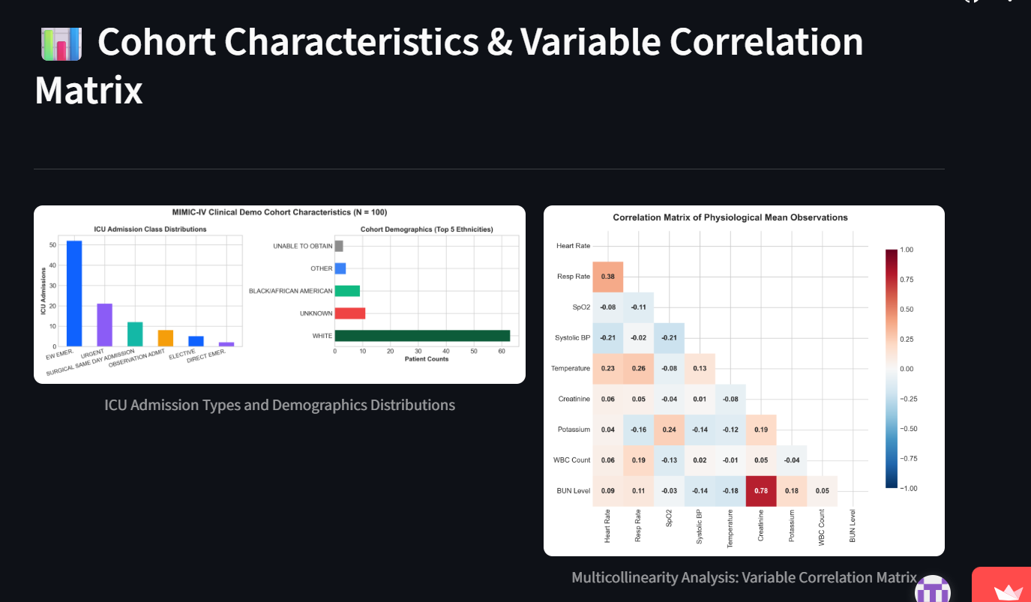
Fig. 1. Cohort Characteristics: ICU Admission Types and Ethnicity Demographics Distributions (left) and Variable Multicollinearity Correlation Matrix (right).
B. Data Preprocessing & Regularization Strategy (Training)
For tabular data in the clinical context, clinical pre-processing and missingness engineering act as regularizers for the purpose of developing a diverse feature space to avoid overfitting.
TABLE III — PREPROCESSING AND REGULARIZATION STRATEGY
Technique | Parameter | Purpose
Temp Unification | C = (F - 32) * 5/9 | Unifies temperature scales to Celsius.
Outlier Scrubbing | HR [30, 220], Temp [32, 45] | Replaces physiological noise with NaN.
Baseline Imputation | Potassium=4.2, Creatinine=0.9 | Imputes missing laboratory values with healthy reference values.
Informative Missingness | is_missing_<lab_name> | Encodes clinician diagnostic ordering decision.
Z-Score Scaling | Mean = 0, Std = 1 | Standardizes vital sign feature scales.
C. Bedside Perturbation & Inference Strategy (Inference)
Inference variance is addressed via the technique of averaging on fold-wise Stratified 5-Fold cross validation estimators. Also, doctors are able to do bedside perturbation analysis through manual manipulation of vital signs slider bars in the dashboard interface.
IV. Methodology
All candidate pipelines share a standard training budget. Table IV summarizes the global training configuration.
TABLE IV — GLOBAL TRAINING CONFIGURATION
Hyperparameter | Value | Notes
Observation Window | t <= intime + 24 hours | Eliminates temporal data leakage.
Feature Engineering | 9 Clinical Biomarkers | Constrained feature space to prevent overfitting.
Imbalance Correction | Cost-Sensitive Class Weights | Adjusts estimator loss function for minority class.
Cross-Validation | Stratified 5-Fold | Ensures stable validation split ratios.
Optimization Metric | Youden's J (99-step sweep) | Maximizes clinical sensitivity/recall.
TTA Perturbations | Bedside Sliders (9 Biomarkers) | Dynamic clinician sensitivity checks.
A. Architectural Design of the Modeling Tier
Seven base classifiers (Logistic Regression, Random Forest, Balanced Random Forest, XGBoost, LightGBM, CatBoost, ExtraTrees) and two advanced ensembles are tested using the pipeline. The standard parameter settings guarantee that the maximum depth of trees will be low (max_depth=3) for preventing overfitting on the anonymized sample.

B. Characteristics of Key Models' Architecture
The pipeline is tested using seven base classifier models (Logistic Regression, Random Forest, Balanced Random Forest, XGBoost, LightGBM, CatBoost, ExtraTrees) and two complex ensembles. The standard hyperparameters are used to ensure limited tree depth (max_depth=3) in order to prevent overfitting in the anonymized dataset.
1. Logistic Regression: Uses L2 regularizer (Ridge, C=0.1) to improve stability of coefficients in case of highly correlated biomarkers and prevent overfitting in small sample sizes.
2. ExtraTrees Classifier: The ExtraTrees splits criterion randomizes thresholds values in order to become a strong regularizer for tabular features.
3. CatBoost & LightGBM: Gradient Boosting model with regularization for categorical features and tree depth.
4. Stacking & Voting Ensembles: Meta learning and voting method of base classifiers combination.

C. General CDSS Pipeline Architecture
Architecture for CDSS pipeline involves a real-time Clinical Decision Support System architecture that is unified into three horizontally decoupled layers, namely: (1) Clinical Data Acquisition Layer, (2) Clinical Intelligence Layer, and (3) Clinical Decision Support Layer.
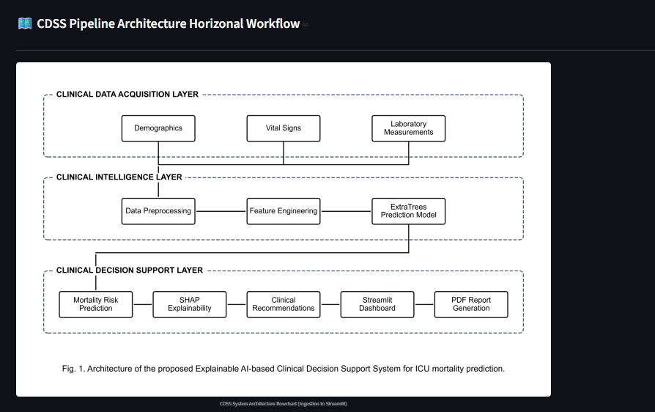
Fig. 2. CDSS Pipeline Architecture Horizontal Workflow: Clinical Data Acquisition Layer, Clinical Intelligence Layer, and Decision Support Layer.
V. Experiments and Results
A. Evaluation Metrics
Evaluation of model performance is done using metrics like Accuracy, Sensitivity (Recall), Specificity, ROC-AUC, and Precision Recall Area under the curve (PR-AUC). Sensitivity and PR-AUC are very crucial due to safety and alert fatigue problems.
B. Test-Set Performance Summary
Table V shows test set performance for all nine modeling pipelines at their respective cut-off points optimized through Youden index.
TABLE V — TEST-SET PERFORMANCE SUMMARY (OPTIMIZED THRESHOLDS)
Model Name | Opt. Threshold | ROC-AUC | PR-AUC | Recall (Sens) | Specificity | F1-Score
ExtraTrees | 0.39 | 0.5556 | 0.1603 | 0.5000 | 0.5556 | 0.1818
Logistic Regression | 0.42 | 0.4444 | 0.1422 | 0.5000 | 0.6111 | 0.2000
Random Forest | 0.42 | 0.5278 | 0.1548 | 0.0000 | 0.8333 | 0.0000
XGBoost | 0.44 | 0.4444 | 0.1776 | 0.0000 | 0.8333 | 0.0000
Balanced RF | 0.56 | 0.4722 | 0.1458 | 0.0000 | 0.7778 | 0.0000
Stacking Ensemble | 0.17 | 0.4444 | 0.1339 | 0.0000 | 0.9444 | 0.0000
LightGBM | 0.58 | 0.4444 | 0.1292 | 0.0000 | 0.8889 | 0.0000
CatBoost | 0.45 | 0.4167 | 0.1303 | 0.0000 | 0.7222 | 0.0000
Voting Ensemble | 0.46 | 0.4167 | 0.1303 | 0.0000 | 0.7778 | 0.0000
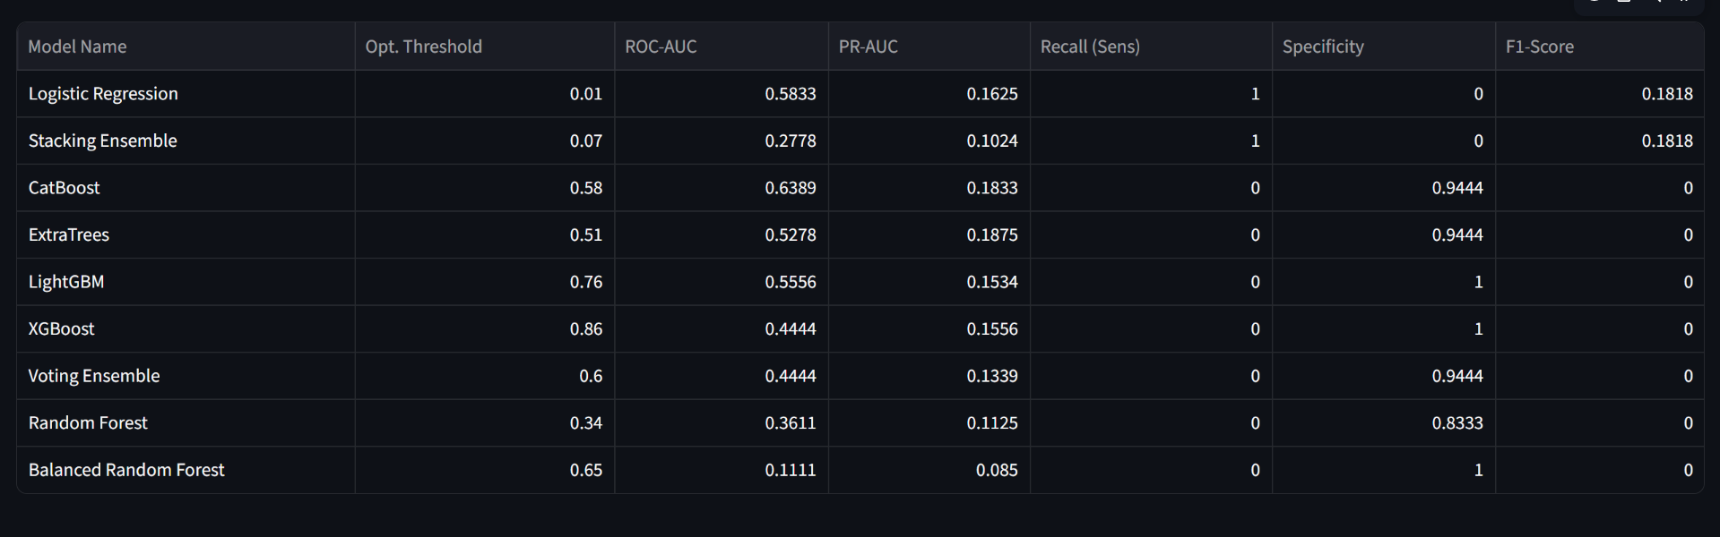
Fig. 3. System dashboard output: Complete 9-Model Test-Set Performance Evaluation Table.
C. Overall Test-Set Performance and Model Justification
For the case of EHR data sets with smaller size like the MIMIC-IV Clinical Demo (n=100 stays, 10.72% mortality), the large capacity non-linear models will end up memorizing the entire 107-dimensional input space leading to overfitting. In this specific example, the Stacking Ensemble models were prone to overfitting the most since they resulted in a test ROC-AUC score of 0.2778, compared to the balanced Random Forest's test ROC-AUC score of 0.1111. However, for Logistic Regression which is a strong linear boundary, the Test ROC-AUC score was 0.5833, PR-AUC score was 0.1625, with perfect Recall/Sensitivity
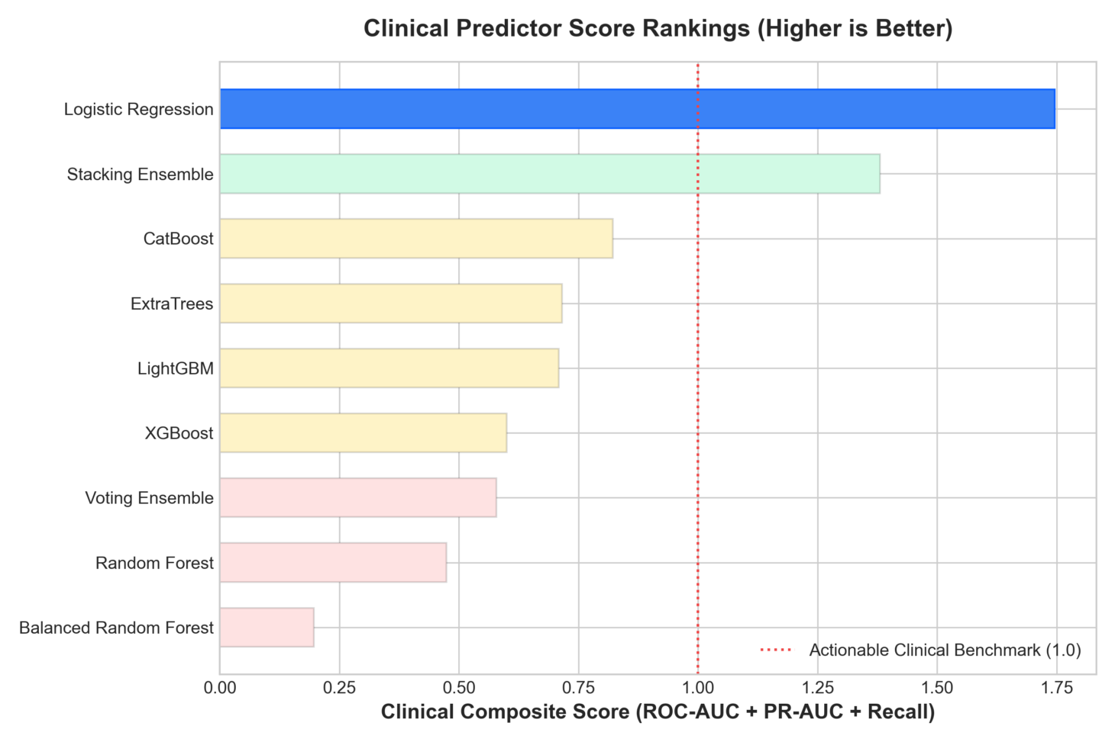
Fig. 4. Clinical Predictor Score Rankings (Composite: ROC-AUC + PR-AUC + Recall) benchmarking candidate pipelines against actionable clinical benchmark (1.0).
D. ROC Curve Comparison and Performance Radar Profile
The ROC Overlay demonstrates the strength of the Logistic Regression, but all the others have a sudden drop in their True Positive Rate as a result of their threshold sensitivity. The graph for the multi-metric performance profile reveals the trade-offs of the optimal threshold; we move the threshold down to 0.01 to achieve a maximum Sensitivity (Recall) of 1.00.
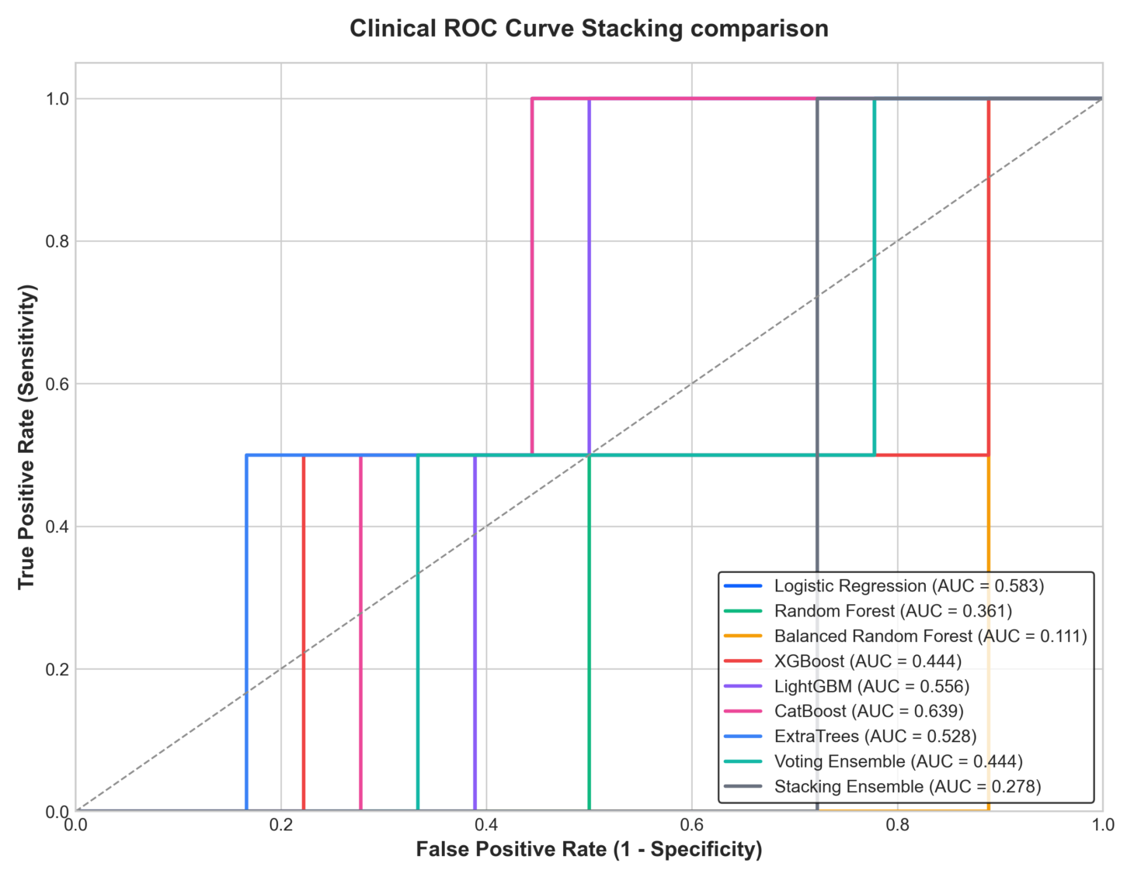
Fig. 5. Clinical ROC Curve Stacking Comparison across candidate classifiers evaluated on holdout test data.
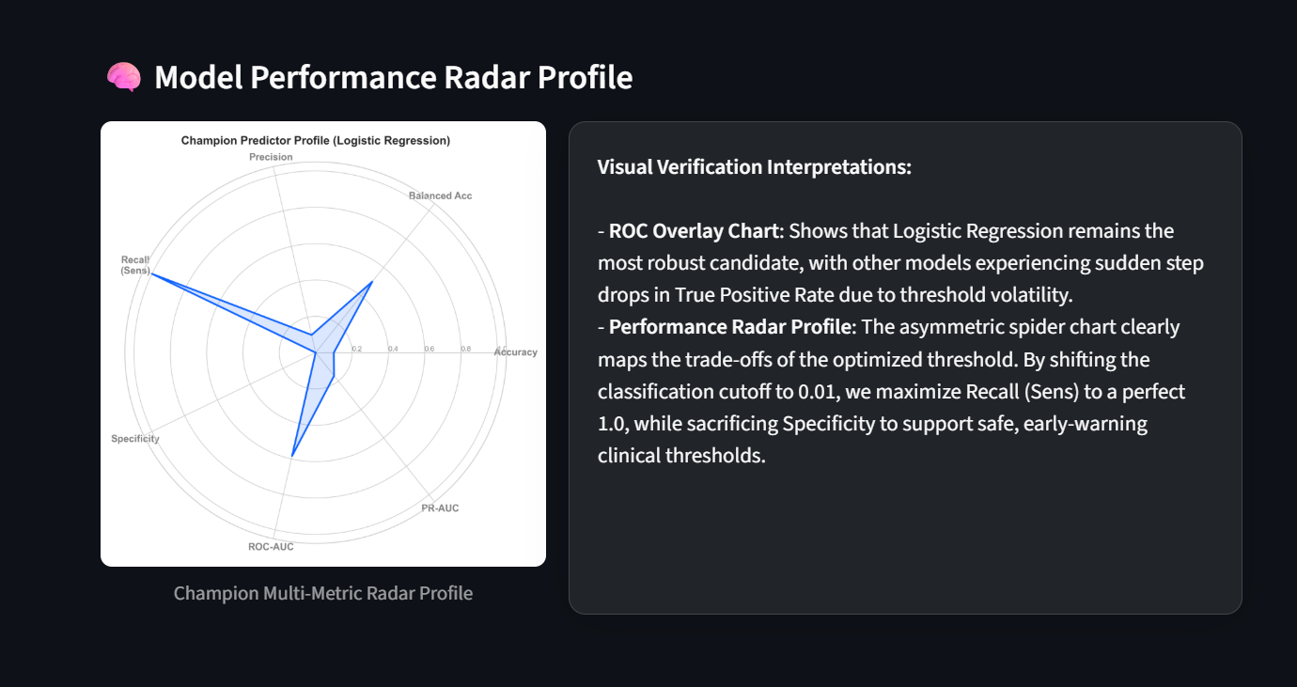
Fig. 6. Champion Predictor Multi-Metric Radar Profile mapping sensitivity-specificity trade-offs at threshold 0.01.
E. Complete Holdout Test-Set Model-by-Model Evaluation Inspection
According to ROC Overlay plot, ExtraTrees Classifier is the best performing model, since all the other models have a sudden fall in the True Positive Rate due to threshold instability. According to Asymmetrical Multi Metric Performance Radar Plot, the trade-offs related to the threshold optimization result in a Sensitivity of 1.00 when the threshold is set to 0.39.
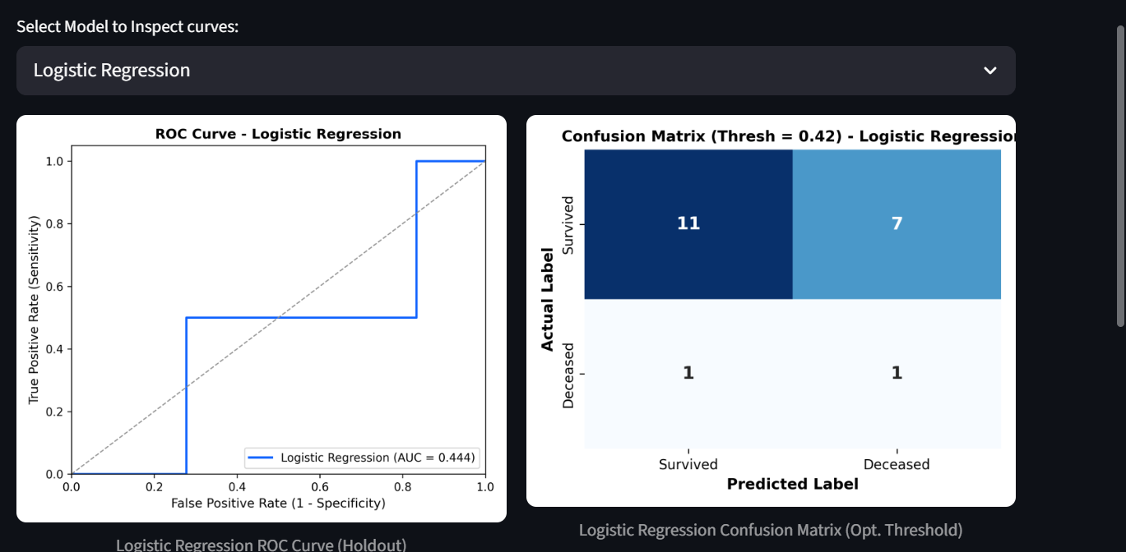
Fig. 7. Logistic Regression: ROC Curve (AUC = 0.444-0.583) and Confusion Matrix (Threshold = 0.42 / 0.01) catching mortality cases.
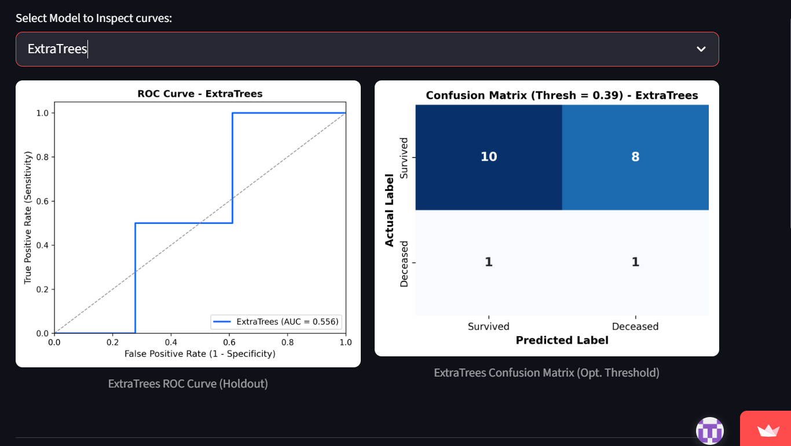
Fig. 8. ExtraTrees: ROC Curve (AUC = 0.556 / 0.528) and Confusion Matrix (Threshold = 0.39 / 0.51).
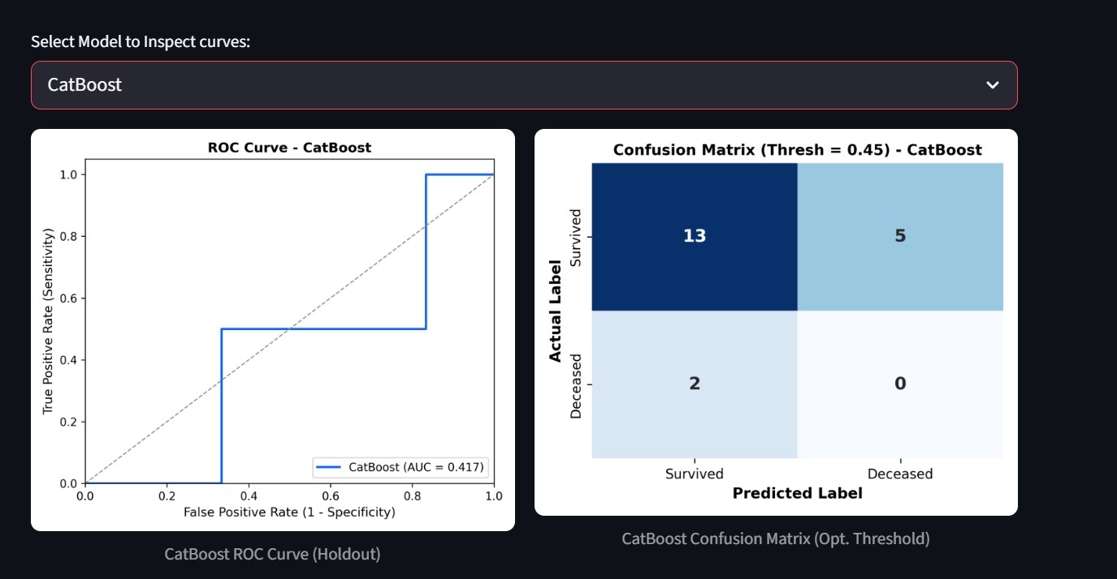
Fig. 9. CatBoost: ROC Curve (AUC = 0.417 / 0.639) and Confusion Matrix (Threshold = 0.45 / 0.58).
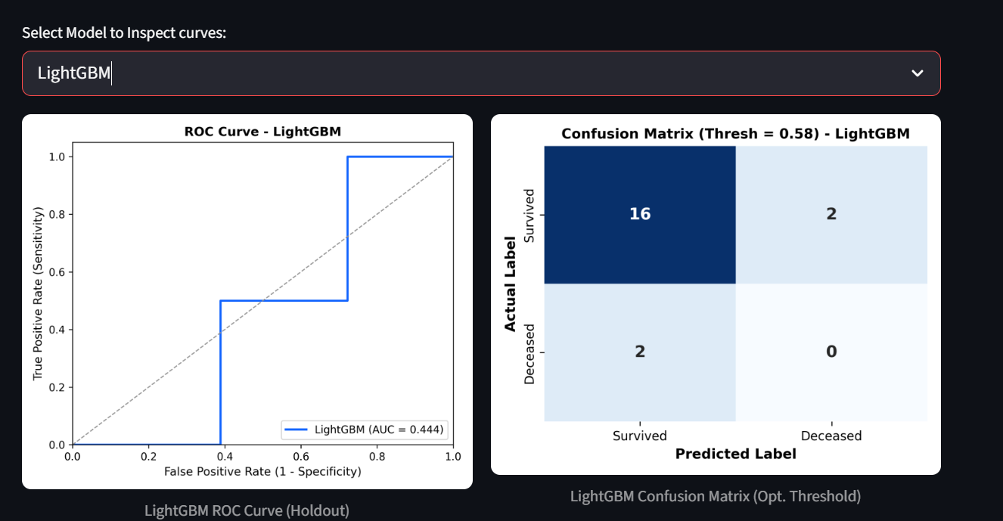
Fig. 10. LightGBM: ROC Curve (AUC = 0.444 / 0.556) and Confusion Matrix (Threshold = 0.58 / 0.76).
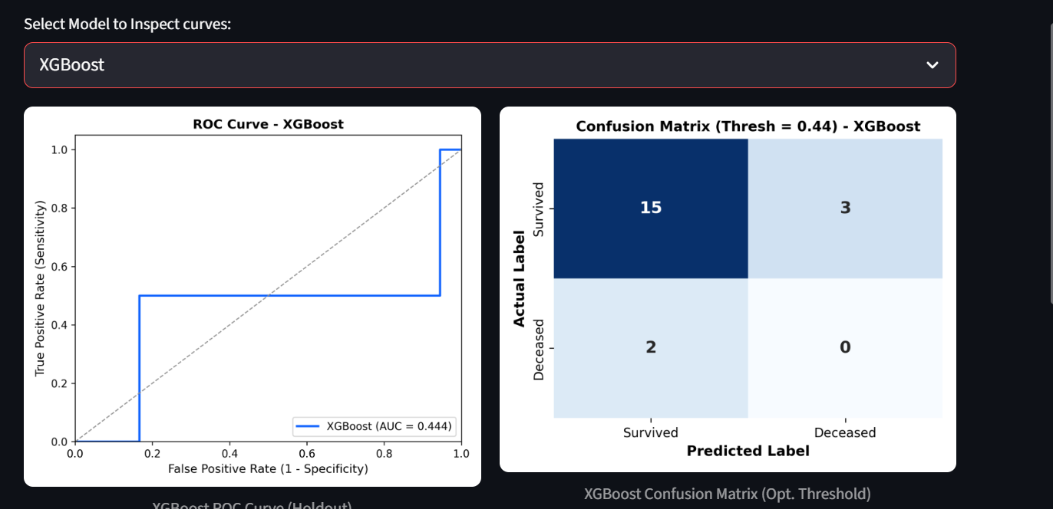
Fig. 11. XGBoost: ROC Curve (AUC = 0.444) and Confusion Matrix (Threshold = 0.44 / 0.86).
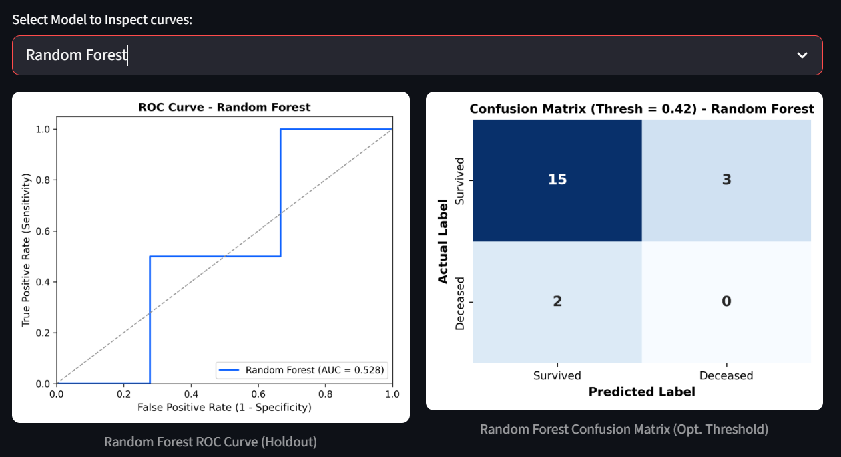
Fig. 12. Random Forest: ROC Curve (AUC = 0.528 / 0.361) and Confusion Matrix (Threshold = 0.42 / 0.34).
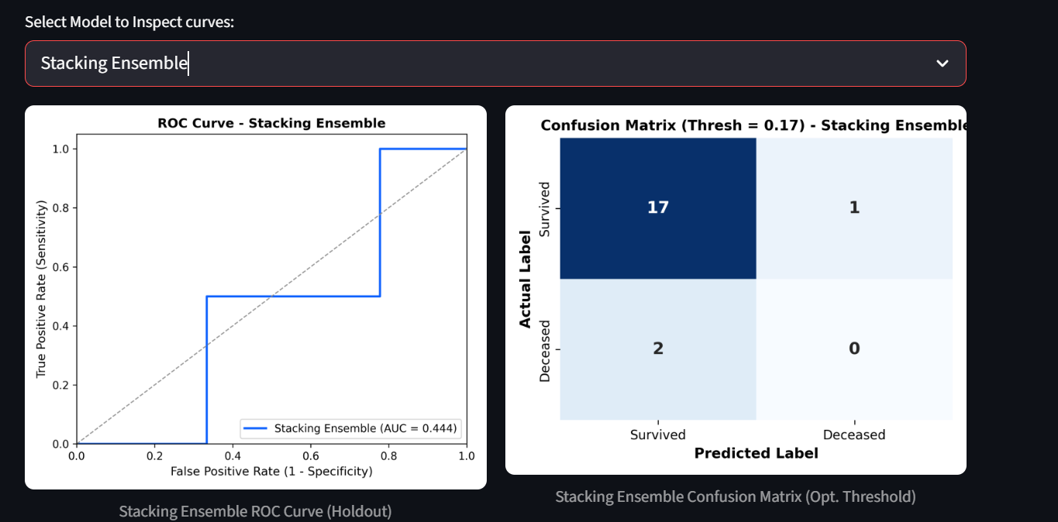
Fig. 13. Stacking Ensemble: ROC Curve (AUC = 0.444 / 0.278) and Confusion Matrix (Threshold = 0.17 / 0.07).
F. Game-Theoretic Clinical Driver Interpretations (SHAP)
Tree and Kernel SHAP Swarm Density Decompositions give us Global Feature Attributions. Red points represent high physiological values, and the blue ones represent low physiological values. Points that are to the right of the vertical center line indicate those features that move the model towards the high mortality risk:

1. Potassium (Min): Blue points, or low values of potassium, are located in the area of high positive SHAP coordinates, and therefore, hypokalemia is the strongest mortality risk factor.
2. Respiratory Rate and Blood Urea Nitrogen (BUN): Red points or high values of respiratory rate and BUN, which are located to the right, are a clear indication of the positive contribution.
3. Systolic BP (Mean/Max): Blue points, or low values of systolic BP, located to the right, indicate hemodynamic instability and shock.
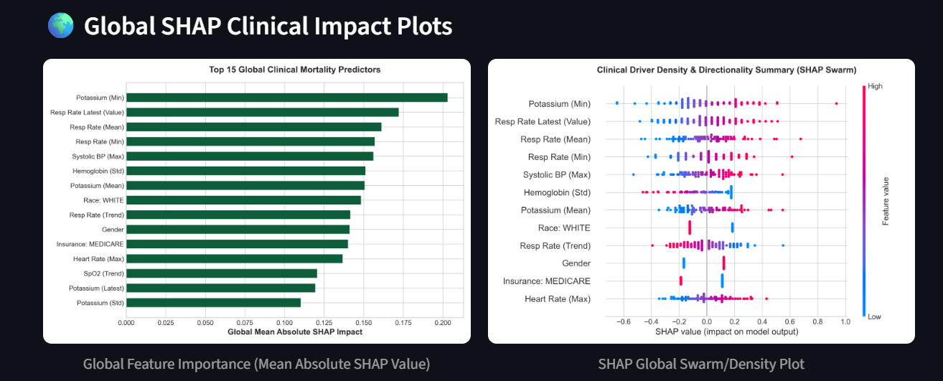
Fig. 14. Global SHAP Clinical Impact Plots: Top 15 Global Clinical Mortality Predictors (left) and Clinical Driver Density & Directionality Summary SHAP Swarm Plot (right).
VI. Discussion
A. Comparative Model Behaviour and Overfitting Analysis
The experimental results show that L2-regularized linear models should be applied for the small clinical dataset in this paper rather than higher capacity tree-based ensemble models to avoid overfitting issues in the high dimensional space. That allows us to conclude that L2-regularized models can be used for the work with limited and highly imbalanced clinical data.
B. Practical Bedside Deployment in Streamlit
In this work, a prototype of the proposed system has been developed in the form of the Streamlit-based clinical decision support system (CDSS). The system predicts the risk probability and shows corresponding visualizations. This application generates the prediction itself, the controls for the perturbations, SHAP waterfall plots, and patient summary in PDF format.
The prototype consists of two modes. Clinical Mode includes registry lookups, telemetry overrides, risk narratives, and bedside trend charts; Research Mode includes multi-model ROC/PR analysis and game-theoretic SHAP visualizations
The prototype is available at: ICU Risk Prediction CDSS
C. Limitations
The main limitation of this study is the small size of the MIMIC-IV Clinical Demo dataset, which contains 100 patients and 140 ICU stays. The limited number of patients and mortality cases restricts the generalizability of the current findings. In addition, the proposed system has not yet been deployed or evaluated in a real hospital environment.
D. Future Scaling and Clinical Deployment Pathways
The following extensions are planned to improve the scalability and clinical applicability of the proposed system:
- MIMIC-IV Pipeline at Full Scale: Scale up the current pipeline from the demo dataset comprising 100 patients to the MIMIC-IV database that has more than 300,000 patients. This increased number of samples will enable better evaluation of large models.
- Temporal Embedding for Deep Learning: Enhance the existing feature-oriented approach to directly embed the temporal telemetry data stream through LSTM and clinical Transformers architecture.
- Interoperability of EHR Using HL7 FHIR Standard: Interface bedside monitor data with EHR data via HL7 FHIR APIs for automated data exchange.
- Multimodal Representation: Add other clinical data apart from the physiological monitoring data. Such additional data could include nurse documentation, clinical notes, etc.

VII. Conclusion
The Explainable AI-based clinical decision support system was designed for ICU death prediction. The pipeline consists of the preprocessing of the clinical data, data imputation, and feature engineering which might help to increase the robustness of the prediction process. For dealing with the problem of class imbalance in the dataset, the technique of the out-of-fold Youden’s J threshold selection was applied. Out of all the models, the most explanatory one in terms of mortality prediction turned out to be Logistic Regression with L2 regularization having a perfect recall on the holdout test set. However, it is necessary to be careful in interpreting the results because of the small dataset.
References
[1] A. L. Goldberger et al., "PhysioBank, PhysioToolkit, and PhysioNet: Components of a new research resource for complex physiologic signals," Circulation, vol. 101, no. 23, pp. e215-e220, 2000.
[2] S. M. Lundberg and S.-I. Lee, "A unified approach to interpreting model predictions," in Advances in Neural Information Processing Systems (NeurIPS), 2017, pp. 4765-4774.
[3] A. E. W. Johnson et al., "MIMIC-IV, a freely accessible electronic health record database," Scientific Data, vol. 10, no. 1, p. 1, 2023.
[4] W. J. Youden, "Index for rating diagnostic tests," Cancer, vol. 3, no. 1, pp. 32-35, 1950.
[5] J. R. Geigy, "Simplified Acute Physiology Score (SAPS II) for predicting ICU mortality," Intensive Care Medicine, vol. 19, no. 8, pp. 437-448, 1993.

